1. **Import pandas and read in the Ecommerce Purchases.csv file and set it to a DataFrame called ecom.**
2. **Check the head of the DataFrame.**
3. **How many rows and columns are there?**
4. **What is the average Purchase Price?**
5. **What were the highest and lowest purchase prices?**
6. **How many people have English 'en' as their Language of choice on the website?**
7. **How many people have the job title of "Lawyer"?**
8. **Split the ‘job’ column into ‘Designation’ & ‘Filed’.**
9. Plot a Bar graph of purchase price.
10. Create a Histogram of purchase price.
11. Write a Python program to draw line charts of the financial data of Alphabet Inc. between October 3, 2016 to October 7, 2016.    
    Sample Financial data (fdata.csv):  
    Date,Open,High,Low,Close  
    10-03-16,774.25,776.065002,769.5,772.559998  
    10-04-16,776.030029,778.710022,772.890015,776.429993  
    10-05-16,779.309998,782.070007,775.650024,776.469971  
    10-06-16,779,780.47998,775.539978,776.859985  
    10-07-16,779.659973,779.659973,770.75,775.080017

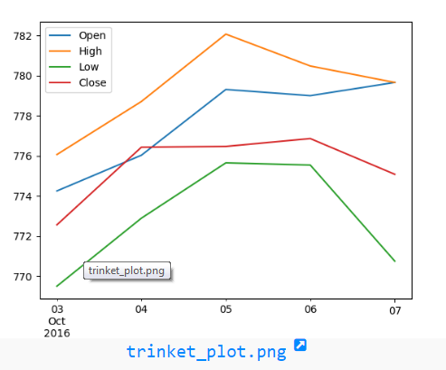

1. Take thes two lists and plot two or more lines and set the line markers.

x = [1,4,5,6,7]

y = [2,6,3,6,3]

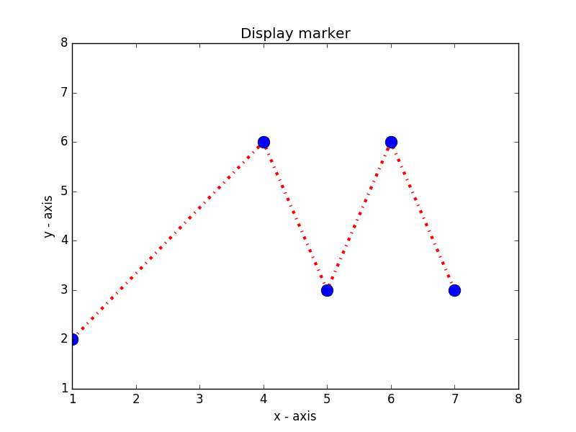

1. Import ‘Marketing_Analysis.csv’, check and display number of null values in each column and clean the data using suitable methods (by mean, mode, median) for each column. Perform the following tasks also.
   1. Univariate Analysis on Job column by plotting bar graph.
   2. Bivariate Analysis on Age, Salary and Balance by plotting Scatter, Pair plot and Correlation Matrix.
   3. Perform multivariate analysis on “Education”,”Marital”,”Response” by creating pivot table and plotting into Heatmap.